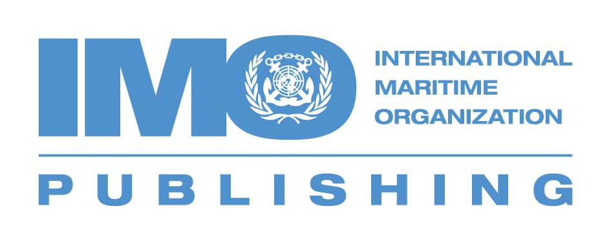

4 Albert Embankment
London SE1 7SR
United Kingdom

Tel: + 44 20 7735 7611
Fax: + 44 20 7587 3241

Email: copyright@imo.org

www.imo.org

Copyright permission request

Sales items published by the International Maritime Organization (IMO) are protected by copyright in accordance with the Berne Convention for the Protection of Literary and Artistic Works, and IMO welcomes requests for permission to reproduce its material.

Credit should be given as follows:

“Material from the IMO publication [reference to extract: Title, Edition] is reproduced with the permission of the International Maritime Organization. The quoted material may not be a complete and accurate version of the original publication and the original publication may have subsequently been amended.”

Please send us your copyright permission requests by email, fax or mail. If you are requesting permission for multiple titles, please submit one form for each title:

Information about the IMO title/material you wish to reproduce
Full title (incl. page numbers for excerpts):
Year of publication, ISBN (if applicable):

Details about yourself/your organization
Individual:
Commercial company:
Non-profit organization:
Postal and e-mail address:

Intended use
Commercial Non-commercial
Type (e.g. book, CD, DVD, magazine etc.) and format:
Title, author:
Publisher, language, publication date:
Print run and sales prices (hardcover and paperback):
Total number of pages, territory (global or specific countries), audience:
Web posting*
Site hosting the material, duration of posting, audience:
Type of access: free paying secure
* To reproduce material posted on the IMO website on your website, please create a link to the item on the IMO website rather than downloading the material from our site. If you decide to create a link, you do not require IMO’s copyright clearance.

Photocopies and course packs
Name of instructor:
Institution, department:
Course name and number, semester:
Expected enrolment:

Additional information:

